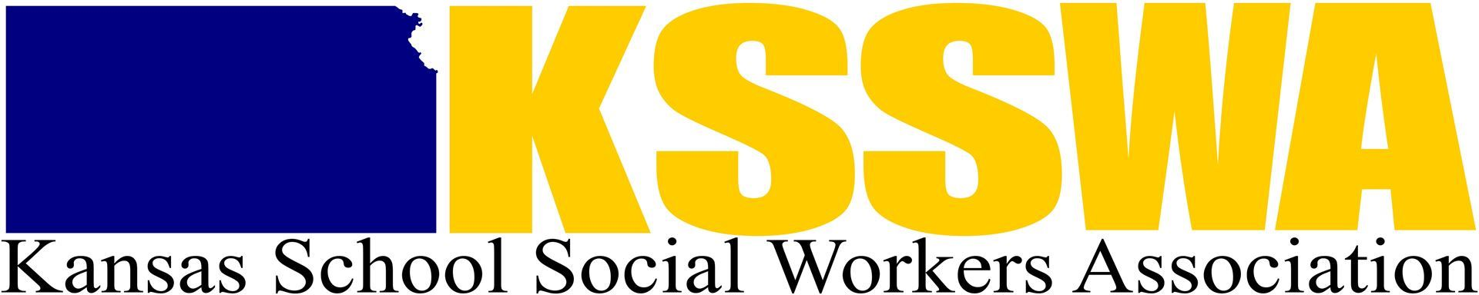

2023 Kansas School Social Worker of the Year
Nomination Form

The School Social Worker of the Year will be honored at the Spring Conference and at the Midwest School Social Work Conference.

The Nominee must be employed as the current school social worker and have worked two or more years as a school social worker in the state of Kansas. Please submit a picture of the nominee, as well as any letters of support from other colleagues who also wish to support this nomination.

Please email your nomination form to Teresapalmer@usd475.org Deadline: March 10, 2023

Name:

Address:
Work:

Home:

Phone: (W) (H)

Work Email Address:

Personal Information:

Educational Experience:

Professional Experience:

Presentations, Publications, Achievements, Recognitions:

Professional Memberships:

Name and Address of School District Supervisor(s):

Name and Address of School District Superintendent:

Exact spelling of nominee’s name, including credentials if desired:

Your Name and Contact Information:

BRIEF SUMMARY OF NOMINEE ACCOMPLISHMENTS
Submit a summary that will be read aloud at the Spring Conference and at the Midwest School Social Work Conference, should the nominee receive the School Social Worker of the Year Award. This should include the primary characteristics and contributions of the nominee that led to your selection. Thank you.

